EXPERIMENT ENVIRONMENT
1. Problem definition:
Tracking randomly moving targets in WMSN/DSN.
- Input:
  - Set of fixed-position directional sensors S = {s₁, s₂,…, s_{n}}.
  - Set of randomly moving targets T = {t₁, t₂,…, t_{m}}.
- Output: Direction of each sensor at each time-step:
$$\{δ_{1,t+1} ,δ_{2,t+1} ,…,δ_{n,t+1} \}$$
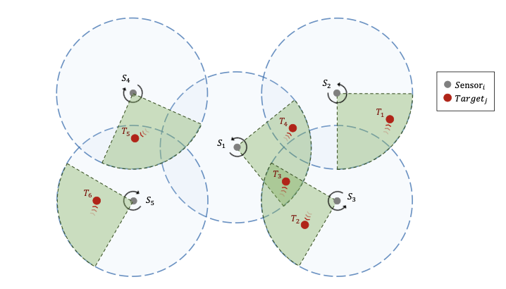
- Constraints:
  - All the sensors have the same fixed sensing range ρ_{max} and FoV = α_{max.}
  - Direction of sensor s_{i} at t+1 is $δ\text{i,t+1}$ and can be changed ($± ∆δ = ± 5^{o}$)
or stayed (0º).
  - There are obstacles/no obstacles in an environment
- Objective:
  - Maximizing number of tracked targets by the sensors.
  - Can apply in large-scale sensor networks.

2. Model - POMMDP:
It is natural to formulate the target coverage problem in n sensors networks as a Dec-POMDPs [15]). It is governed by the tuple ⟨N, S, {Ai}i∈N , {Oi}i∈N , R, P r, Z⟩ where:
- N is a set of n agents, indexed by {1, 2, ..., n}
- S is a set of world states;
- Ai is a set of primitive actions available for agent I, and forming joint actions a⃗t = (a1,t , ..., an,t ) with others;
- Oi is the observation space for agent i, and its local observation oi,t ∈ Oi is drawn from observation function Z(oi,t|st,⃗at);
- R : S → R is the team reward function, shared among agents;
- P r : S × A1 × ...An × S → [0, 1] defines the transition probabilities between states over joint actions. Notably, the subscript t ∈ {1, 2, ...} denotes the time step.
3. Environment:
Our environment simulation is set within a bounded, two-dimensional area. At the start of each episode, we randomly scatter n sensors and m targets throughout the space. The targets then move at random velocities along unpredictable paths for the duration of the episode. This setup allows for a dynamic simulation of real-world target tracking and coverage scenarios within the constraints of DSNs.
Observation Space: At each discrete time step, every sensor i constructs its local observa- tion, oi = (oi1, oi2, . . . , oim), which encapsulates its spatial relationships with all m targets in the environment. Each element oij of this vector is the observation towards target j in the environment, defined as a tuple (i, j, ρij , αij ), where i and j denote the unique identifiers of the sensor and target. ρij and αij are the absolute distance and relative angle, respectively, within a polar coordinate system centered at sensor i. The model’s comprehensive observation, ⃗o = (o1, o2, ..., on), is subsequently formed by aggregating the individual obser- vations received from all n sensors.
Action Space: The set of elementary actions available to the sensors includes three discrete options: TurnLeft, TurnRight, and Stay. The TurnLeft and TurnRight actions change the sensor’s absolute angle δi 5◦ per step (i.e. δi,t+1 = δi,t ± 5◦). The model uses a n × m binary matrix goal map ⃗g, where gij is a binary value (0: No, 1: Yes) that indicates whether target j has been assigned to sensor i. The target assignment of sensor i can be shown in the row ith of the matrix.
We will do experiment in 2 scenarios: small-scale environment and large-scale environment. Assume that sensing range ρ_{max} of each sensor is the same and ρ_{max} = 18m.
Scenario 1: The first scenario introduces a large-scale environment structured as a 3 × 3 grid (size of each grid cell is 20m x 20m). In this environment, the position of the sensors is the center of the grid cell (number 1,3,5,7,9 as the figure below), resulting in a total of n = 5 sensors and m = 6 targets across the grid.

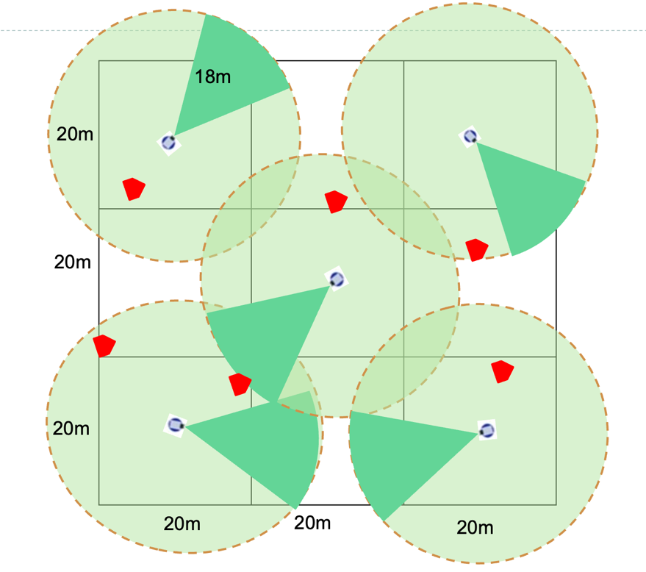
Scenario 2: The second scenario introduces a large-scale environment structured as a 10 × 10 grid (size of each grid cell is 20m x 20m, as in the figure below), designed to test the model’s scalability and adaptability. In this environment, sensor placement is probabilistic, with each grid cell assigned a uniform probability of sensor deployment. A threshold probability of 50% determines the overall sensor distribution, resulting in a total of n = 50 sensors and m = 60 targets across the grid. This probabilistic placement strategy is intended to emulate the inherent uncertainties and logistical constraints often encountered in real-world sensor network deployments. To further refine the experimental setup, the radius of each sensor was adjusted to ensure that the circular detection area produced by a sensor is confined to a single grid cell. This modification facilitates enhanced control over sensor coverage, thereby more accurately simulating conditions where sensors possess limited detection ranges and must be strategically oriented to optimize coverage within the environment.
